Tatton Wildlife Newsletter – Winter

There is still plenty to see out in the parkland during the winter months and there are many benefits to getting out and experiencing all that Tatton has to offer. Nature is constantly changing, and signs of spring’s imminent arrival can come very early in the new year even during the winter months.
Birds
The spread of ring-necked parakeets over the country has been well documented. Here at Tatton, we have had infrequent sightings over the years, but we all knew it was a matter of time before we had a more regular presence. This is now the case with birds now seen on a regular basis. The parakeets are suspected to oust other hole nesting birds and, having at least three pairs of green woodpeckers breeding here and perfect habitat for both them and ring-necked parakeets, the thought of losing green woodpeckers as a breeding species is a concerning prospect. We are in the early stages of monitoring this alongside Salford University.
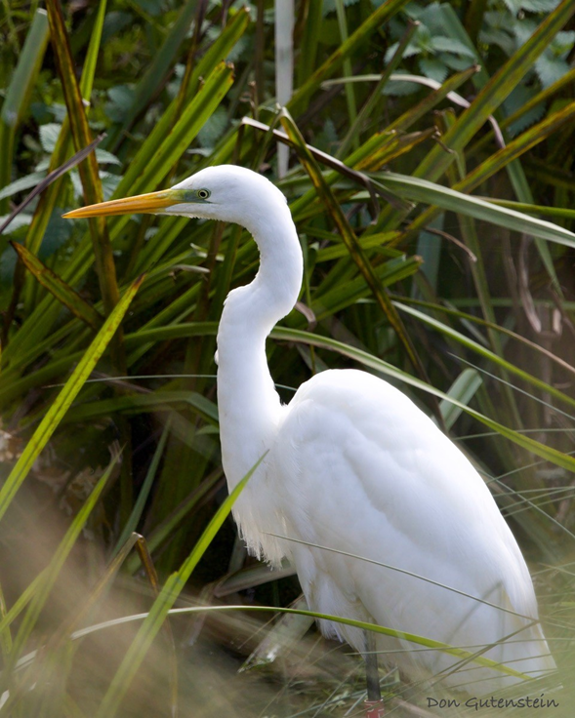
Another success story from the bird world has graced us with his presence from early October in the form of a great white egret. A welcome visitor and still present at the time of writing, he is frequently seen at the outflow of Tatton Mere. He has an obvious ring on his leg which was possible to read and after contacting the relevant people, we discovered that this bird is part of a project. This bird, red ring number AFU, was ringed in the nest on 29/4/24 at RSPB Ham Wall and is a male. It was one of a brood of 3, one of which failed to fledge, and the other was a female which has been reported in Oxfordshire.

Butterfly Survey
In line with national trends, the Tatton transect performed poorly in 2024. The results were stark with 649 individuals seen compared to last year’s 1945. Only 13 species were recorded after recording 18 in 2023. Incredibly, amongst those missing were common species including small tortoiseshell and comma. The most numerous species was meadow brown with 257 records, which compares unfavourably with last year’s 1095, lowest was red admiral with only 2 records after 19 in 2023. The best recording day was 8th July when 197 individuals were seen, including 108 Ringlets. A small number of species showed an increase on last year’s totals, these were orange tip, brimstone and ringlet. But the trend was overwhelmingly downwards. Tatton’s most interesting record occurred off transect, when a bedraggled green hairstreak was found on 31st July.
Deer
The deer have now finished the rut and moulted into their winter coats. The longer guard hairs on the winter coats are hollow which allow them to trap air within them and will provide insulation. The ranger team will feed the deer daily with carrots over winter to make sure that they maintain body condition during the harsher months. During particularly cold spells, haylage will be provided too.

The photographs shown here were taken at Tatton and kindly supplied by Don Gutenstein
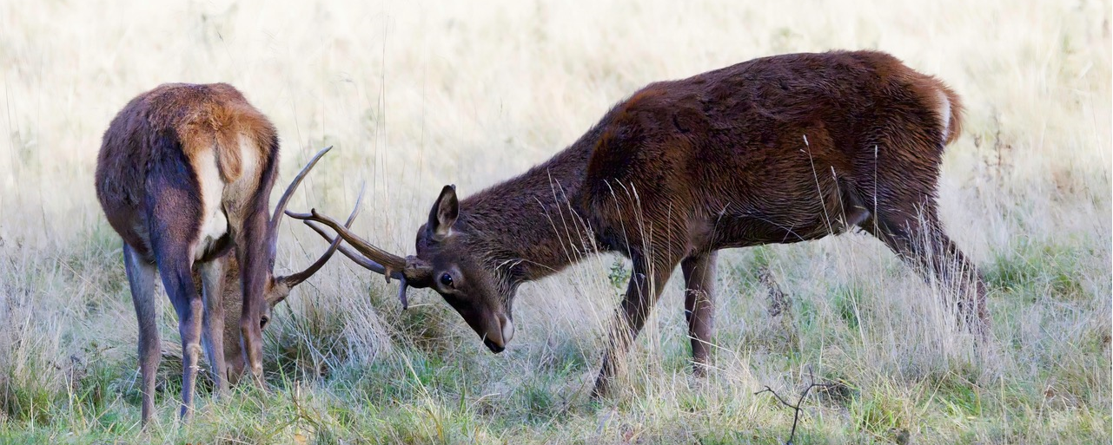
Compiled by Tatton’s Ranger Team

